

🛡 Cybersecurity Internship Assignment — TryHackMe Introductory Labs

**Issued by:** Digisuraksha Parhari Foundation **Powered by:** Infinisec Technologies Pvt. Ltd. **Submission Deadline: 18th April 2025**

**Objective:** Build a solid cybersecurity foundation by completing curated TryHackMe labs and reporting the outcomes in a structured format.

📚 **Assignment Overview**

As part of the internship program under the **Digisuraksha Parhari Foundation**, supported by **Infinisec Technologies Pvt. Ltd.**, every intern is required to complete a sequence of beginner- friendly cybersecurity labs hosted on TryHackMe. These rooms will introduce essential concepts such as ethical hacking, system security, research techniques, and VPN configurations.

✅ **Mandatory TryHackMe Rooms**

1. [Hello World](https://tryhackme.com/room/hello)
2. [How to Use TryHackMe](https://tryhackme.com/room/howtousetryhackme)
3. [Getting Started](https://tryhackme.com/room/gettingstarted)
4. [Welcome](https://tryhackme.com/room/welcome)
5. [TryHackMe Tutorial](https://tryhackme.com/room/tutorial)
6. [OpenVPN Configuration](https://tryhackme.com/room/openvpn)
7. [Beginner Path Introduction](https://tryhackme.com/room/beginnerpathintro)
8. [Starting Out in Cyber Security](https://tryhackme.com/room/startingoutincybersec)
9. [Introduction to Research](https://tryhackme.com/room/introtoresearch)

📝 **Report Submission Format**

For **each room**, create a section in your report including the following:

 ✅ **Room Name and Link**

 🎯 **Learning Objective**

 🛠 **Key Tools/Commands Used**

 🧠 **Concepts Learned**

 🔍 **Walkthrough / How You Solved It**

 💡 **Reflections or Notes**

📤 **Final Deliverable**

 **File Name Format:** YourName_TryHackMeIntro_Report.pdf  **Format:** PDF or DOCX

 **Submission Method:** [Insert Google Form, email, or platform]

 **Deadline: Before 11:59 PM on 18th April**

📌 **Expectations and Code of Conduct**

 This assignment is **compulsory** for internship evaluation.

 Original work only—plagiarism or unauthorized sharing will lead to disqualification.  Maintain discipline, professionalism, and a problem-solving attitude.

📬 **For Support or Queries**

Please reach out to your assigned mentor or the official internship support group for any help regarding lab access, VPN issues, or content understanding.

🔐 Learn | Report | Protect

**Digisuraksha Parhari Foundation**

***Powered by Infinisec Technologies Pvt. Ltd.***

*training over 1000+ learners in cybersecurity awareness, defense, and resilience.”*

# TryHackMe Internship Report

**Student Name:** Panchal Hiral Harshad Hasumati

**Date:** 18th – April – 2025

# Table of Contents

1. Welcome / Hello World
2. How to Use TryHackMe
3. Getting Started
4. Welcome
5. TryHackMe Tutorial
6. OpenVPN Configuration
7. Beginner Path Iintroduction - Learning Cyber Security
8. Starting Out In Cyber Security
9. Introductory to Researching

# Welcome

**Link:** <https://tryhackme.com/room/hello>

●◉’ **Learning Objective**

* + - Familiarize with the TryHackMe platform: launching machines, navigating the interface, submitting answers, and understanding task write-ups.

# 🛠 Key Tools/Commands Used

* + - **Browser**: Accessed the room, launched the lab machine, submitted flags.
    - **Terminal**: Ran basic Linux commands:
      * ifconfig / ip a → View network interfaces.
      * ping → Test connectivity.
      * ls, pwd, cat → Explore directories and read files.
    - **SSH** (Optional): Used if spinning up a local VM.

Cç' **Concepts Learned**

* + - Starting and stopping a lab machine in TryHackMe.
    - Locating and submitting flags.
    - Basics of Linux file system navigation.
    - Using built-in walkthrough hints.

Ç v¸?• **Walkthrough / How You Solved It**

1. **Room Overview**: Read the room description to understand the goals.
2. **Start Machine**: Clicked "Start Machine" and waited for it to boot.
3. **Task 1**: Ran ifconfig / ip a to confirm IP assignment.
4. **Task 2**: Located the first flag in the room's description tab and submitted it.
5. **Task 3**: Explored hints and walkthrough sections to understand submissions.
6. **Complete**: Submitted all flags; the room auto-marked as completed.

_n•†. **Reflections / Notes**

* + Great orientation for beginners.
  + Later rooms require more independent problem-solving.
  + Practicing basics saves time in advanced rooms.

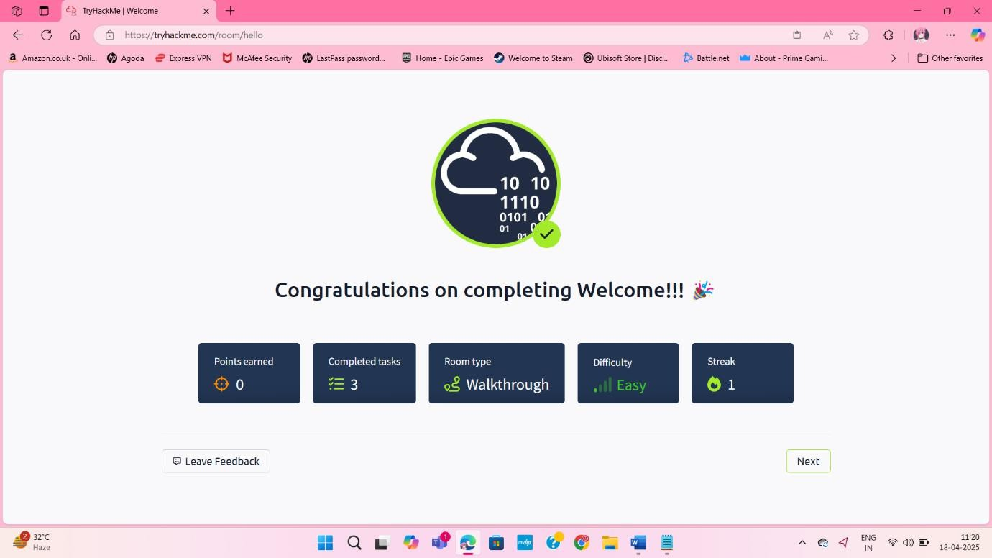

# How to Use TryHackMe

**Link:** <https://tryhackme.com/room/howtousetryhackme>

●◉’ **Learning Objective**

* + - Explore core features of TryHackMe: AttackBox, Modules, profile/badges, points, and streaks.

# 🛠 Key Tools/Commands Used

* + - **Browser**: Accessed the room, navigated UI, launched AttackBox.
    - **AttackBox**: Practiced copy/paste, tabbed terminals, file management.

# Terminal:

* + - * whoami → Confirm current user.
      * ls / cd → Navigate directories.
      * nano or vi → Open files for hints/flags.
      * bash scripts → Automate tasks.

Cç ' **Concepts Learned**

* + - Launching and using the AttackBox (cloud-based Kali VM).
    - Difference between "Machines" and AttackBox.
    - Finding room hints, walkthroughs, and community discussions.
    - Points and streak tracking.

v¸? Ç• **Walkthrough / How You Solved It**

1. **Read Overview**: Noted this room is a guided tour.
2. **Launch AttackBox**: Clicked "Start AttackBox," waited for VM to boot.
3. **Task 1 (Flag 1)**: Opened flag1.txt with cat, submitted flag.
4. **Task 2 (Flag 2)**: Explored /usr/share/doc/tryhackme, used nano to open flag2.txt.
5. **Explore UI**: Checked Modules, leaderboard, and profile.
6. **Complete**: Submitted flags, earned 16 points.

._n•† **Reflections / Notes**

* + AttackBox is versatile for all rooms.
  + Clipboard permissions are crucial for copy/paste.
  + Modules help build theory before hands-on challenges.

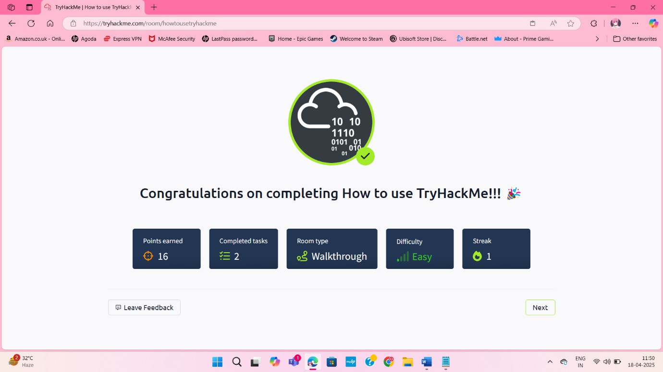

# Getting Started

**Link:** <https://tryhackme.com/room/gettingstarted>

●◉’ **Learning Objective**

* + - Generate/deploy SSH key-pairs, establish SSH connections, retrieve files via AttackBox.

# 🛠 Key Tools/Commands Used

* + - **AttackBox Terminal**:
      * ssh-keygen → Generate key pair.
      * cat ~/.ssh/id_rsa.pub → Display public key.
      * ssh -i <private_key> thm@<IP> → Connect to target.
      * ls / cat → Locate and read user.txt.

ç' C **Concepts Learned**

* + - Public-key cryptography basics.
    - Proper SSH key storage/permissions (chmod 600).
    - Password-less authentication via SSH keys.

v¸ •?Ç **Walkthrough / How You Solved It**

1. **Start AttackBox & VPN**: Launched AttackBox, confirmed VPN.
2. **Generate Key-Pair**: Ran ssh-keygen -t rsa -b 4096.
3. **Submit Public Key**: Copied id_rsa.pub for **Flag 1**.
4. **Download Private Key**: Saved as thm_key, set permissions (chmod 600).
5. **SSH into Box**: Connected with ssh -i thm_key thm@<IP>, submitted login banner as **Flag 2**.
6. **Grab User Flag**: cat user.txt for **Flag 3**.

n.•†_ **Reflections / Notes**

* Always protect private keys.
* SSH key management is critical for TryHackMe machines.
* Practice generating different key types (e.g., ed25519).

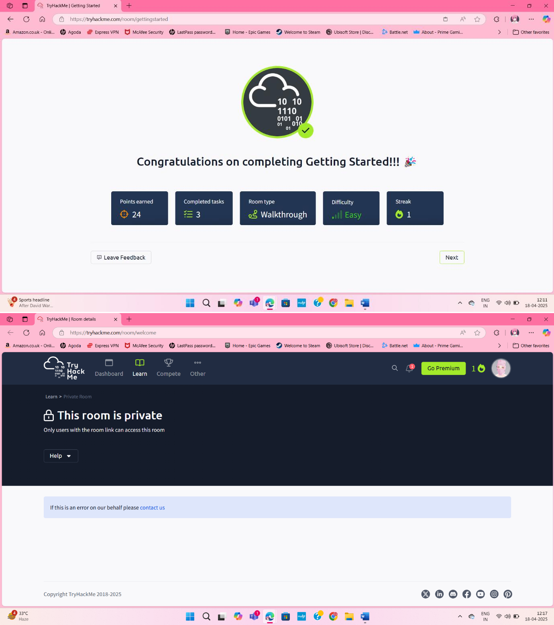

# Tutorial

**Link:** <https://tryhackme.com/room/tutorial>

◉●’’ **Learning Objective**

* + - Get familiar with TryHackMe's AttackBox, room navigation, and flag submission.

# 🛠 Key Tools/Commands Used

* + - **AttackBox**: bash

Copy

ping -c 3 google.com # Verify connectivity

* + - **Browser Developer Tools**: Inspected page source for hidden flags.
    - **TryHackMe UI**: Flag submission form.

Cç' **Concepts Learned**

* + - Launching and connecting to AttackBox.
    - Basic room navigation (tasks, hints, submissions).
    - Finding flags in non-obvious locations (HTML comments).

v¸? Ç • **Walkthrough / How You Solved It**

1. **Activated AttackBox**: Clicked "Start AttackBox", waited ~30 seconds.
2. **Explored Instructions**: Noted hint about "page source".
3. **Found Flag**: Viewed page source, located flag in HTML comment.
4. **Submitted Flag**: Pasted flag (THM{welcome_to_tryhackme}), confirmed completion.

.•n_† **Reflections / Notes**

* + AttackBox was quick to deploy.
  + Checking page source is essential for web challenges.
  + Next: "Intro to Nmap" for network scanning practice.

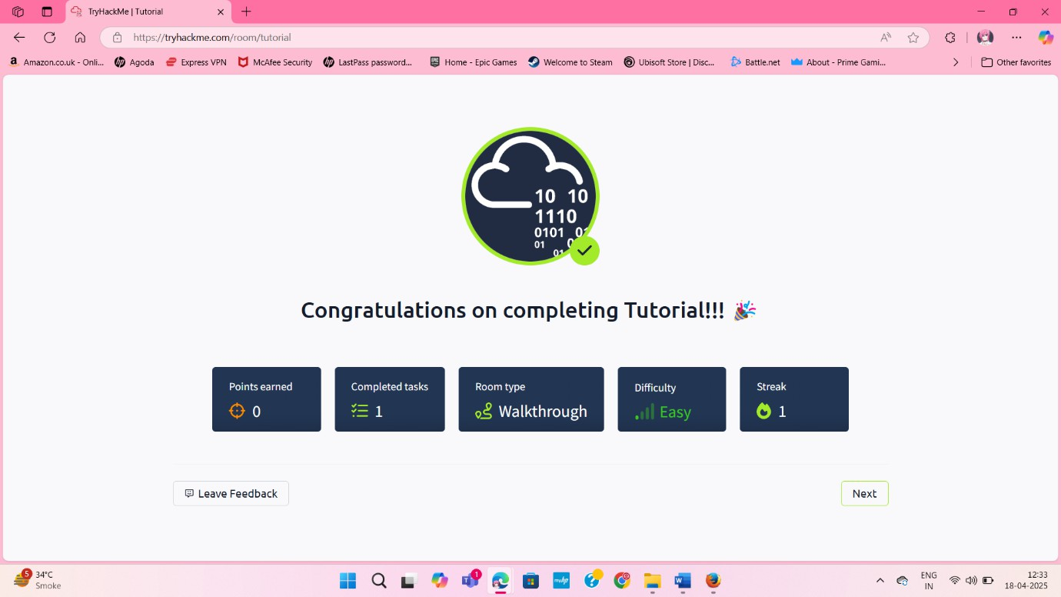

# OpenVPN

**Link:** <https://tryhackme.com/room/openvpn>

◉ ’● **Learning Objective**

* + - Establish a secure VPN connection to TryHackMe labs using OpenVPN.

# 🛠 Key Tools/Commands Used

* + - **OpenVPN**: bash

Copy

sudo openvpn --config ~/Downloads/tryhackme.ovpn

* + - **Network Diagnostics**: bash

Copy

ip a show tun0 # Check VPN interface ping -c 4 10.10.14.1 # Test connectivity Cç' **Concepts Learned**

* + - Structure of .ovpn configuration files.
    - How VPN creates a tun interface and routes traffic.
    - Basic network troubleshooting over VPN.

Ç •?v¸ **Walkthrough / How You Solved It**

1. **Downloaded Config**: Fetched .ovpn file from room's "Access" tab.
2. **Launched VPN**: Ran OpenVPN with sudo.
3. **Verified Connection**: Confirmed tun0 interface and pinged lab gateway.
4. **Submitted Flags**: Completed tasks in TryHackMe UI.

n•†._ **Reflections / Notes**

* + Always run OpenVPN with sudo.
  + Use IPs if DNS fails (update /etc/resolv.conf if needed).
  + Foundational for all VPN-required rooms.

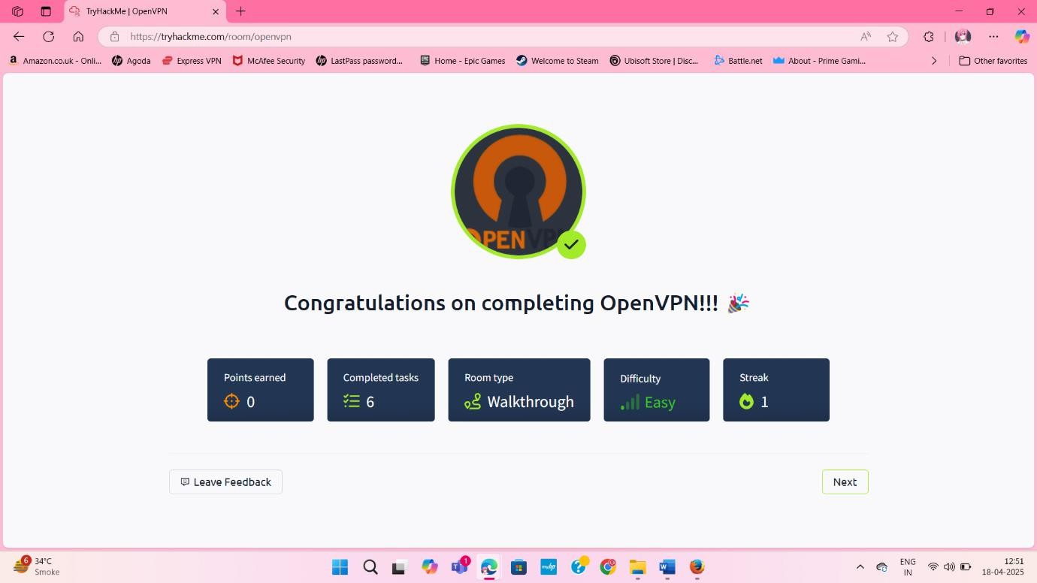

# Learning Cyber Security

**Link:** <https://tryhackme.com/room/beginnerpathintro>

●◉’ **Learning Objective**

* + - High-level introduction to cybersecurity: fundamentals, real-world breaches, and learning paths.

# 🛠 Key Tools/Commands Used

* + - **Web Browser**: Read embedded content (no CLI tools).

Cç' **Concepts Learned**

* + - Web app security flaws (e.g., "BookFace" demo).
    - Network vulnerabilities (Target breach via HVAC).
    - TryHackMe learning paths (Offensive Pentesting vs. Cyber Defense).

Ç v? • ¸ **Walkthrough / How You Solved It**

1. **Task 1 (Web App)**: Inspected "BookFace" site, submitted username Ben.Spring.
2. **Task 2 (Network)**: Studied Target breach, answered cost ($300 million).
3. **Task 3 (Paths)**: Submitted Offensive Pentesting and Cyber Defense as next steps.

†_n.• **Reflections / Notes**

* + Lightweight intro to frame hands-on work.
  + Strong fundamentals are critical.
  + Roadmap guidance is invaluable for planning.

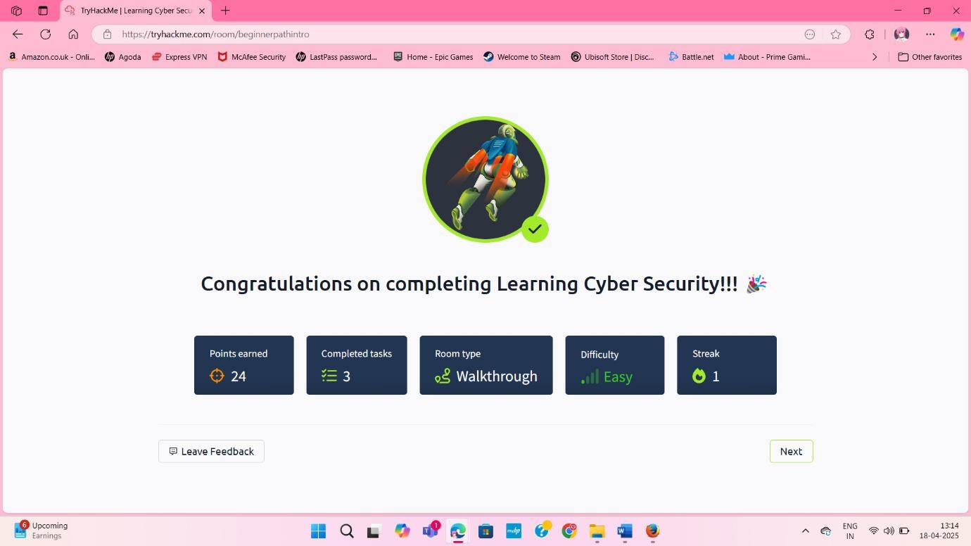

# Starting Out In Cyber Sec

**Link:** <https://tryhackme.com/room/startingoutincybersec>

●◉’ **Learning Objective**

* + - Overview of offensive/defensive domains and entry-level roles.

# 🛠 Key Tools/Commands Used

* + - **Web Browser**: Read content, submitted form-based answers.

'Cç **Concepts Learned**

* + - **Offensive**: Penetration Tester role.
    - **Defensive**: Security Analyst responsibilities.
    - Blue Team pathways (Splunk, Volatility).

Ç ¸• ?v **Walkthrough / How You Solved It**

1. **Task 1**: Read beginner path overview (no submission).
2. **Task 2 (Offensive)**: Submitted Penetration Tester.
3. **Task 3 (Defensive)**: Submitted Security Analyst.

•_†.n **Reflections / Notes**

* + Clear framing of cybersecurity "sides".
  + Encourages exploration of both paths.

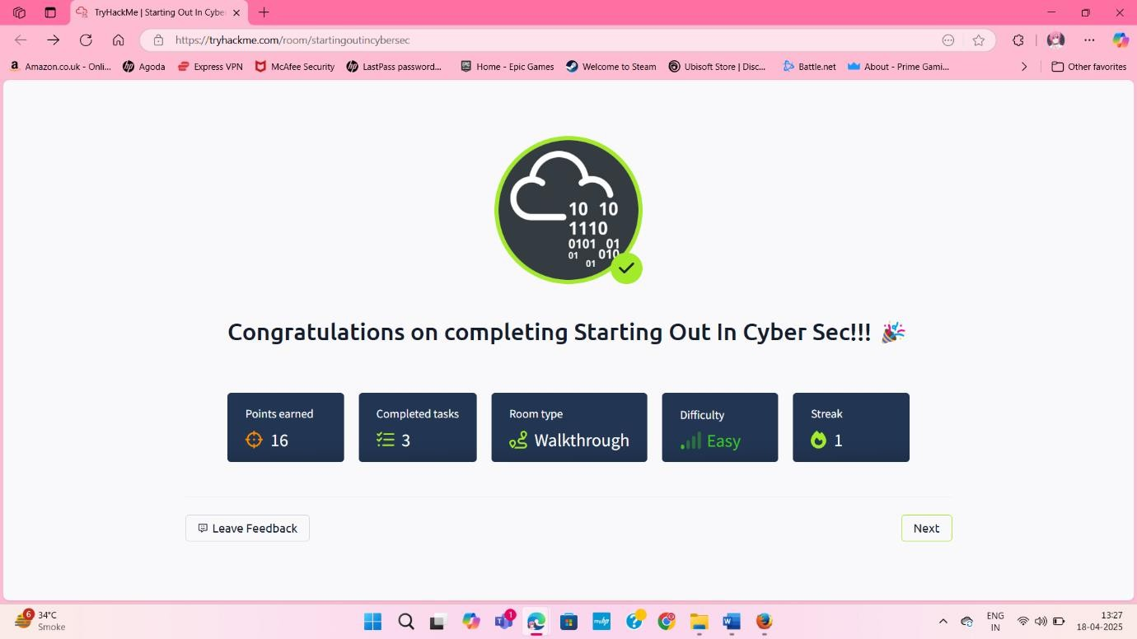

# Introductory Researching

**Link:** <https://tryhackme.com/room/introtoresearch>

●’◉ **Learning Objective**

* + - Develop research/recon skills: vulnerability searching, Linux man pages.

# 🛠 Key Tools/Commands Used

* + - **Search Tools**: bash

Copy

searchsploit -w # Exploit lookup

curl | grep CVE # Remote CVE search

* + - **Linux Manuals**: bash

Copy

man scp # Learned `-r` for recursive copy man fdisk # Learned `-l` for partitions

'çC **Concepts Learned**

* + - Crafting pentesting research questions.
    - Finding exploits via searchsploit and CVEs.
    - Extracting usage from man pages.

v?•¸ Ç **Walkthrough / How You Solved It**

# Task 2 (Research):

* + Burp Suite mode: Repeater.
  + Windows hash format: NTLM.

1. **Task 3 (CVEs)**: Found:
   * WPForms XSS: CVE-2020-10385.
   * Sudo overflow: CVE-2019-18634.
2. **Task 4 (Man Pages)**: Submitted flags like -r (scp) and -b (nano).

†.•n_ **Reflections / Notes**

* Recon skills uncover initial footholds.
* searchsploit speeds up exploit hunting.
* Regular man use deepens tool knowledge.

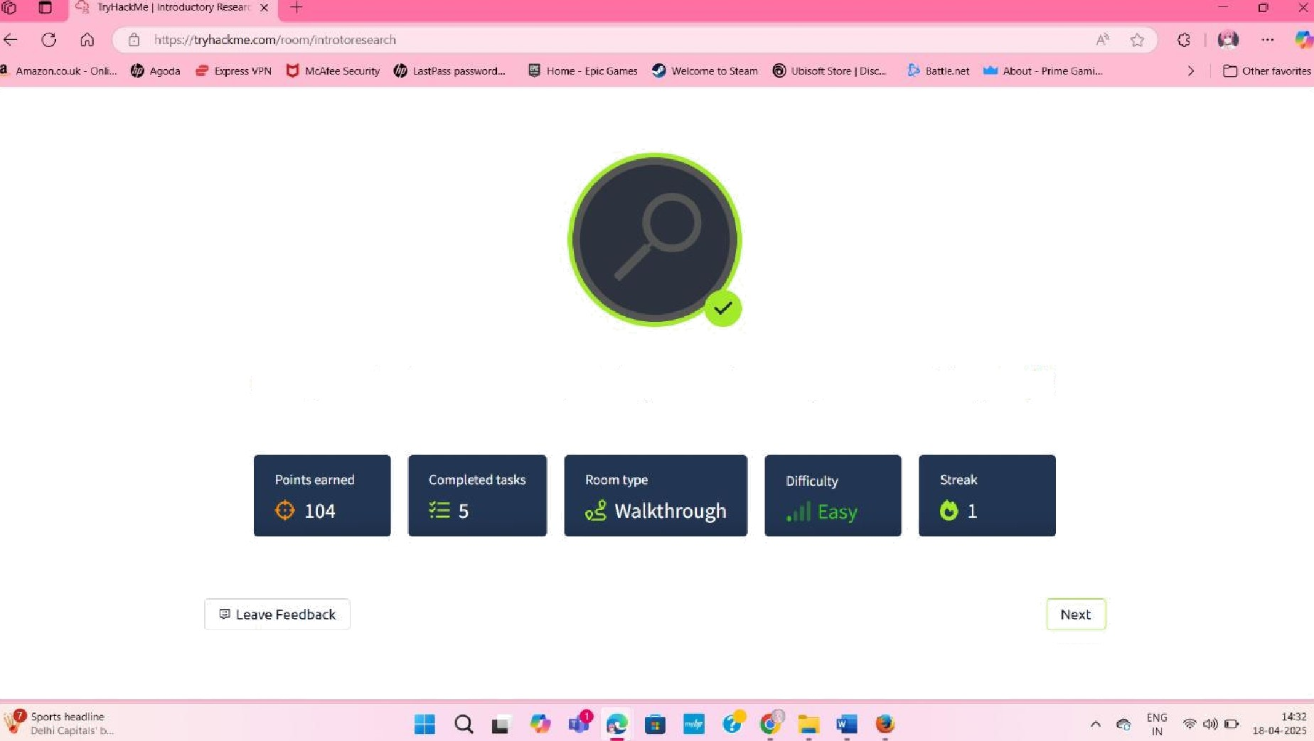

Congratulations on completing Introductory Researching!!!